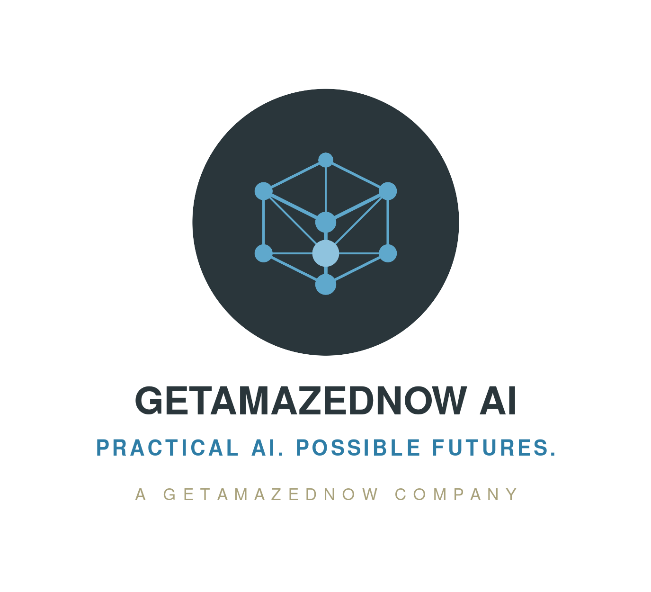
ADSRA · OPEN QUESTION OQ-2
 Hold-your-own-key: surgical or broad?
The question
The architecture recommends that hold-your-own-key (HYOK) and client-side encryption be applied "surgically, not universally." Is that the right line?
Why it matters
HYOK and client-side encryption are the strongest cryptographic-sovereignty controls — and the most expensive. They break real native cloud features: server-side search, some analytics, managed integrations. The "surgical" guidance is a deliberate honest trade-off that needs field evidence, not assertion.
Our current position [a considered view, open to challenge]
Apply client-side encryption / HYOK only to assets whose threat model includes lawful compulsion of the cloud provider. Provider-managed keys for Low; customer-managed keys for Medium and High; HSM-backed customer-managed keys or HYOK for Critical. Applying it everywhere is self-harm.

What we’re seeking from you
A named workload with the before-and-after feature loss and the risk it bought — either vindicating "surgical", or showing a class of workload where broader application paid off.
Where this is most relevant: Banking · Healthcare · Cross-industry / platform engineering

